Diocese of Elphin

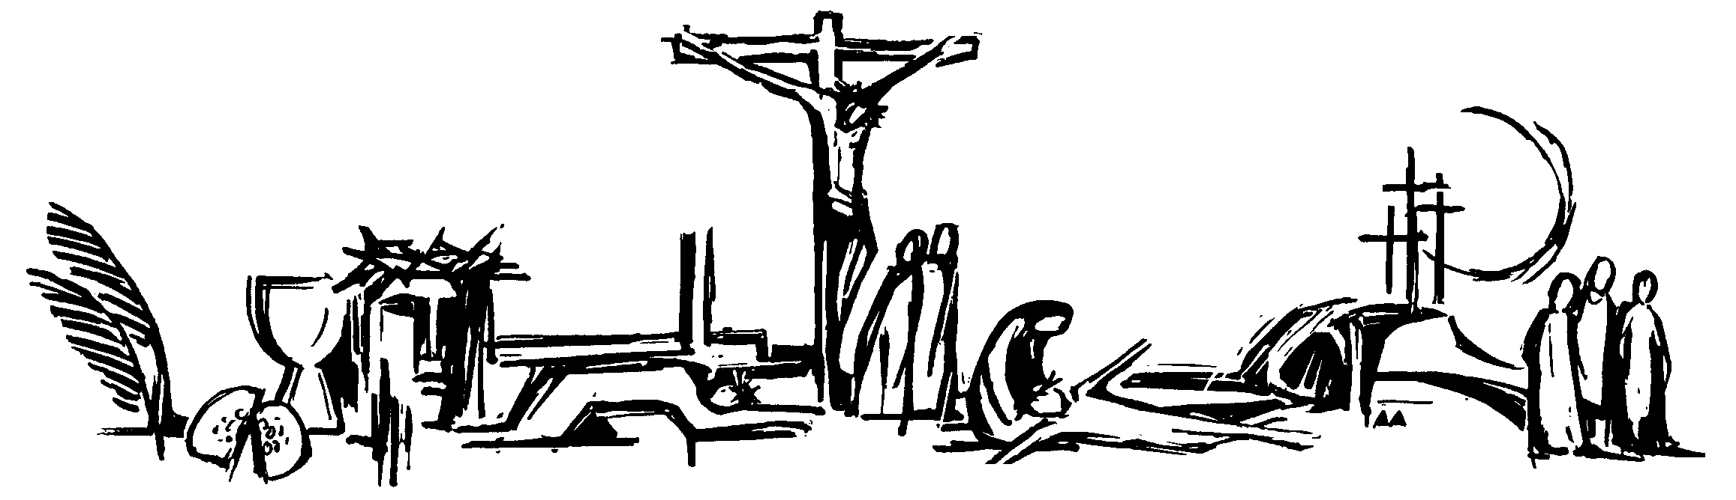

Scripture Sharing Group Prayer Resource

Reader 5: May the dying go forward in hope to meet Christ, their judge; may they see your face and be happy for ever.
R/ Lord, have mercy on your people.

Leader: I invite you to pray aloud any prayer of praise, thanksgiving or petition that is in your heart this morning / evening.
……….
Leader: Following our Lord’s teaching, let us say with faith and trust:
All: Our Father ...

Concluding Prayer
Leader: Bend our wills , Lord,
so that by this Lenten observance we may fit ourselves to celebrate the Easter festival;
and as we have all undertaken to subdue the body, may we be all renewed in spirit.
We make this prayer through Christ our Lord.
All: Amen.

Leader: The Lord bless us, and keep us from all evil, and bring us to everlasting life.
All: Amen.

Leader: Let us bless the Lord.
All: Thanks be to God.

Introduction

Leader: O God, come to our aid.
All: O Lord, make haste to help us.

Leader: Glory to the Father, and to the Son, and to the Holy Spirit:
All: as it was in the beginning, is now,
and ever shall be, world without end. Amen.

A Lenten Hymn
(everyone)

Lord, who throughout these forty days
For us did fast and pray,
Teach us with you to mourn our sins,
And close by you to stay.
As you with Satan did contend,
And did the victory win,
O give us strength in you to fight,
In you to conquer sin.

As thirst and hunger you did bear,
So teach us, gracious Lord,
To die to self, and daily live
By your most holy word.

And through these days of penitence,
And through your Passiontide,
Yea, evermore, in life and death,
Jesus, with us abide.

Psalmody
(with the group dividing in two for the praying of the psalms)

Leader: Lord, you are great, you are glorious, you are wonderfully strong.
.
It is good to give thanks to the Lord
to make music to your name, O Most High,
To proclaim your love in the morning
and your truth in the watches of the night. On the ten-stringed lyre and the lute,
with the murmuring sound of the harp.

Your deeds, O Lord, have made me glad: for the work of your hands I shout with joy. O Lord, how great are your works!
How deep are your designs!
The foolish man cannot know this and the fool cannot understand.

Though the wicked spring up like the grass and all who do evil thrive,
They are doomed to be eternally destroyed. But you, Lord, are eternally on high.
See how your enemies perish, all doers of evil are scattered.

To me you give the wild-ox’s strength; you anoint me with the purest oil.
My eyes looked in triumph on my foes; my ears heard gladly of their fall.
The just will flourish like the palm-tree and grow like a Lebanon cedar.

remembering his mercy;
the mercy promised to our fathers,
to Abraham and his seed for ever.

All: Give praise to the Father Almighty, To His Son Jesus Christ the Lord,
To the Spirit who dwells in our hearts Both now and forever. Amen.

Leader: Truly I say to you, ‘Whoever has faith in me has eternal life’

Intercessions

Leader: God the Father has chosen for himself a people, who are born again, not from any mortal seed but from his everlasting Word. Let us praise his name and turn to him in prayer.
R/ Lord, have mercy on your people.

Reader 2: Merciful God, hear our prayers for all your people; may they hunger more for your word
than for any human food.
R/ Lord, have mercy on your people.

Reader 3: Teach us to love sincerely the people of our nation and of every race on earth; may we work for their peace and welfare.
R/ Lord, have mercy on your people.

Reader 4: Strengthen those who will be reborn in baptism this Easter; make them living stones in the temple of your Spirit.
R/ Lord, have mercy on your people.

Short Responsory

Leader: I said: ‘Lord, have mercy on me.’
All: I said: ‘Lord, have mercy on me.’

Leader: Heal my soul, for I have sinned against you.
All: I said: ‘Lord, have mercy on me.’

Leader: Glory be to the Father and to the Son and to the Holy Spirit.
All: I said: ‘Lord, have mercy on me.’

`
Magnificat

Leader: Truly I say to you, ‘Whoever has faith in me has eternal life’

My soul glorifies the Lord,
my spirit rejoices in God, my Saviour. He looks on his servant in her lowliness; henceforth all ages will call me blessed.
The almighty works marvels for me, Holy his name!
His mercy is from age to age, on those who fear him.
He puts forth his arm in strength and scatters the proud-hearted.
He casts the mighty from their thrones and raises the lowly.
He fills the starving with good things; sends the rich away empty.
He protects Israel, his servant,
Planted in the house of the Lord
they will flourish in the courts of our God,
still bearing fruit when they are old, still full of sap, still green,
to proclaim that the Lord is just.
In him, my rock, there is no wrong.

All: Give praise to the Father almighty, to His son, Jesus Christ the Lord,
to the Spirit who dwells in our hearts, both now and forever. Amen.

All: Lord, you are great, you are glorious, you are wonderfully strong.

Brief Moment of Silence
Leader: On the lips of children and of babes you
have found praise, Lord.

How great is your name, O Lord our God, through all the earth!

Your majesty is praised above the heavens; on the lips of children and babes,
You have found praise to foil your enemy, to silence the foe and the rebel.

When I see the heavens, the work of your hands, the moon and the stars which you arranged, What is man that you should keep him in mind, mortal man that you care for him.

Yet you have made him little less than a God; with glory and honour you crowned him, Gave him power over the works of your hand,

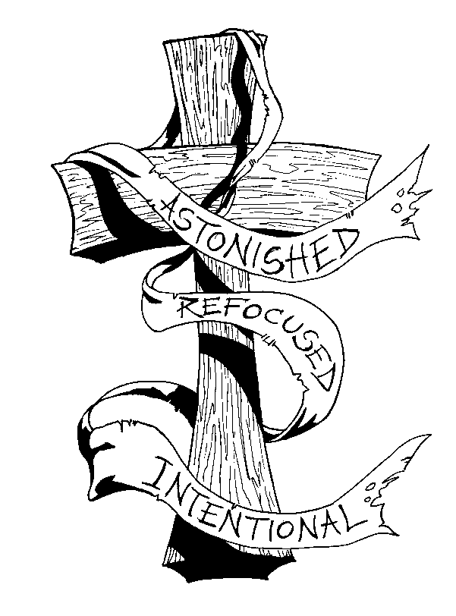
put all things under his feet.

All of them, sheep and cattle, yes, even the savage beasts, birds of the air, and fish
that make their way through the waters.

How great is your name, O Lord our God, through all the earth!

All: Give praise to the Father almighty, to His son, Jesus Christ the Lord,
to the Spirit who dwells in our hearts, both now and forever. Amen.

All: On the lips of children and of babes you have found praise, Lord.

Brief Moment of Silence

Leader: He is the first-born of all creation; he is supreme over all creatures.

Let us give thanks to the Father, who has qualified us to share
in the inheritance of the saints in light.

He has delivered us from the dominion of darkness and transferred us to the kingdom of his beloved Son, in whom we have redemption,
the forgiveness of sins.
He is the image of the invisible God,
the first-born of all creation,
for in him all things were created, in heaven and on earth, visible and invisible.

All things were created through him and for him He is before all things,
and in him all things hold together.

He is the head of the body, the Church; he is the beginning,
the first born from the dead,
that in everything he might be pre-eminent.

For in him all the fullness of God was pleased to dwell, and through him to reconcile to himself all things, whether on earth or in heaven,
making peace by the blood of his cross.

All: Give praise to the Father almighty, to His son, Jesus Christ the Lord,
to the Spirit who dwells in our hearts, both now and forever. Amen.

All: He is the first-born of all creation; he is supreme over all creatures.

Scripture Reading & Reflection

Please use weekly handout which can be downloaded
@ www.elphindiocese.ie/lent

